

Date: | 21st January 2025
Time: | 10:00am – 12:00noon
Venue: | MS Teams
Priority Cluster: | HFE - Education, Health, Social Care, Childcare and Emergency Services

Minutes
Attendees |  | Apologies
Caryn Grimes (CCRSP) | CG | Bethan Stacey (Education Workforce Council) | BS
Dawn Bunn (Clybiau Plant Cymru) | DB | Casey French (Care Forum Wales) | CF
Helen Scarrett (South Wales Police) | HS | Jon Day (Social Care Wales) | JD
Kathryn Wing (Educ8 Training) | KW | Kevin Morgan (Cardiff University) | KM
Leanne Jones (Merthyr College) | LJ | Matt Brown (WCVA) | MB
Nick Ounsworth (South Wales Fire) | NO | Scott McKenzie (Open University) | SM
Rabia Ceylan *Guest Speaker (Talent Beyond Boundaries) | RC
Rachel Mooney (HEIW) | RM
Sarah Allbeson (Open University) | SA
Vikki Stroud (CCRSP) | VS

Welcome, introductions and apologies (Kathryn Wing, Educ8)

- KW welcomed members and reported the apologies listed above
- The group made introductions for the benefit of new members and guest speakers at the meeting.

Actions from the last meeting (Caryn Grimes, CCRSP)

ACTION: DB to share results of sector survey
COMPLETE - Dawn on agenda 21st January 2025

ACTION: VS Annual agenda item for EWC to attend & present workforce statistics.
COMPLETE - Bethan on agenda 21st October 2025 as this is aligned to the statistics publish date which is July

ACTION: EJ & CG cross reference the ESB Skills & Employment Plan and the Social Care Wales plan
COMPLETE – Meeting for CG & EJ incomplete, in the meantime action completed via JD who provided links which were distributed to the group.

ACTION: CCRSP distribute the group's RAG-rated action plan, members should report any missing activities within the plan.
COMPLETE – sent again 7th October 24.

ACTION: JD to share the information about the EWC event with CCRSP to circulate to the group.
COMPLETE – Enclosed in minutes 18th Sept

ACTION: LJ, JD & PML get together to discuss mapping their work & resources to work, across Health, Social Care and Early Years and Childcare.
ROLLED OVER - LJ to take this action forward and report in next meeting.

ACTION: CG Reshare the NOS document with the group, new deadline of 30th September for further comments to be added.
COMPLETE - sent out to the group following the last meeting.
ACTION: CCRSP reshare the RAG action plan again with request for additional comments.
COMPLETE – sent again 7th October 24.

ACTION: VS to contact Emily Draper at Educ8 regarding FacetoFace meetings
ROLLED OVER: VS to contact Emily Draper to move meetings F2F from Jan and July to April and October.

ACTION: CCRSP to share the Medr consultation registration details with the cluster group.
COMPLETE - sent 7th October 24

ACTION: CG to share with JD the PLA provision report from CV
COMPLETE – CG shared with JD on 7th October 24

ACTION: VS/CG request written updates from any members who are not present in future meetings.
COMPLETE – VS will request for future meetings.

Minutes were signed off as accurate and complete. The previous meeting minutes are enclosed below as several new members to the group.

NO requested that CG send him the RAG & NOS, as he has not received them from Luke.

ACTION: CCRSP send NO RAG rated report and NOS for this cluster

Sector Survey Results (Dawn Bunn, Clybiau Plant Cymru Kids’ Club)

- Dawn Bunn (National Training Manager) from Clybiau Plant Cymru Kids’ Clubs provided an update on the 2023 sector survey. The most recent survey from 2024 closes on 31st January 2025; findings are not yet being processed, and more detailed information will be available in the coming months.
- Dawn explained that "Clybiau, Plant Cymru, Kids Clubs" is the voice of the out-of-school childcare sector. The organisation also offers training, in addition to its advocacy role.
DB presentation is enclosed at the bottom of this section, with a summary of the key points provided below;
- The new sector survey has revealed that 35% of members are concerned about the financial stability of the out-of-school childcare sector, with 50% relying on other services for after-school childcare. 18% are reducing their opening hours to make services more sustainable, while 21% are closing elements of their services. This is a concern, as many people are already on the waiting list for childcare. 10% of clubs are deregistering due to the reduced hours or the difficulty of registration.
- Children's mental health and well-being are still struggling, with a legacy from COVID-19. The increased number of children with additional learning needs is a significant issue for the sector, as it has physical and financial implications for staff and children with more complex needs. There are also gaps in knowledge in safeguarding across the sector, with the ministerial play review highlighted the lack of reporting and recording.
- The fewer people accessing training to become qualified play workers is a key problem, as people get disillusioned with the training being delivered by child carers rather than play workers. City & Guilds are withdrawing their playwork qualifications, which could impact organisations' willingness to find a new provider.
- In conclusion, the sector survey highlights the challenges faced by the out-of-school childcare sector, including financial stability, mental health, and the need for better safeguarding knowledge.
- Focus, an awarding organisation that offers playwork, is not on the list of required qualifications for playwork in Wales. This means that a Level 3 qualification with Focus would not grant a license to practice in Wales. The only training provider with the agreement to deliver these qualifications is Adult Learning Wales, as well as Clybiau, Plant Cymru. There are many training options available, including training and support funding, apprenticeship funding, and Welsh delivery.
- The City and Guilds withdrawal is due to a lack of demand from the sector to commit time and effort to rewrite their qualifications. As a result, NCFE will no longer be accepting registrations for playwork levels 2–3 or 5 as of December. Transition awards are important because they allow individuals to transition from Level 2 childcare programs to play work practice, which is also offered by Adult Learning Wales.
- CG believes that the next steps should be to lobby the Welsh Government to address the skills gap in playwork and childcare. They usually lean towards FE and HE and other relevant committees, but there are currently several scrutiny committees going on.
- The Welsh Government closely collaborates with the group and provides funding, enabling them to advocate for ongoing qualification. The more people speak out about the issue, the more reason for them to take action.

ACTION: DB to send CCRSP copy of the presentation slides for distribution in the minutes (completed, enclosed below)

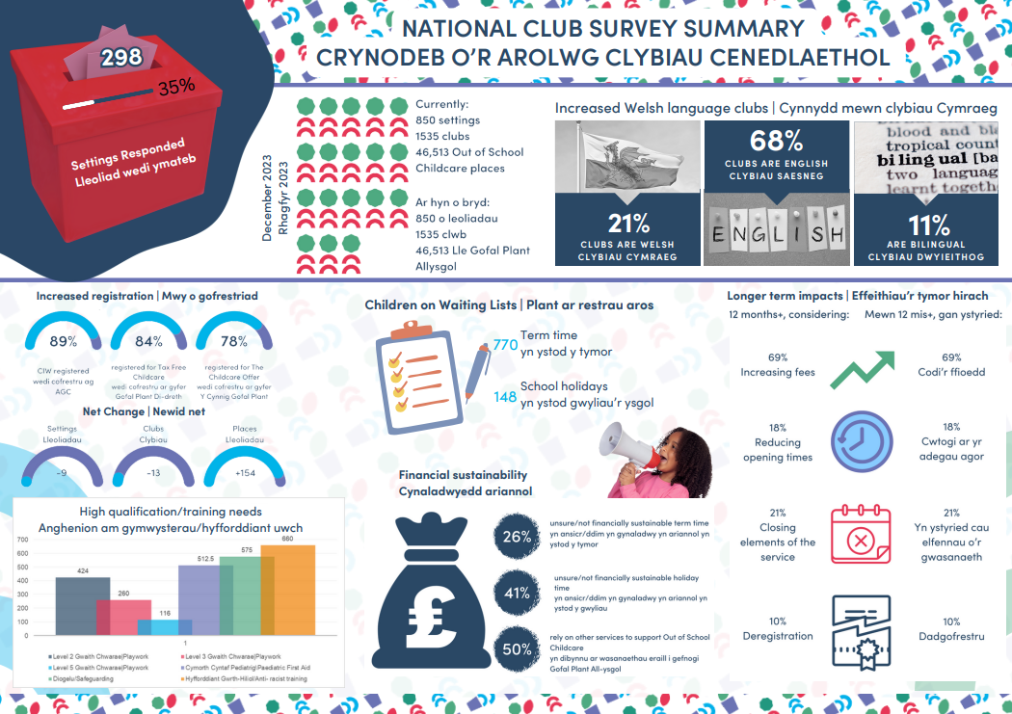

Talent Beyond Boundaries: helping skilled refugees and displaced people in Wales (Rabia Ceylan, UK Healthcare Manager)

- Rabia Ceylan, UK Healthcare Manager at Talent Beyond Boundaries, discussed her organization's efforts to address skills shortages by connecting skilled refugees with employment opportunities. Launched 10 years ago in response to the Syrian refugee crisis, the organization is now operating in countries worldwide. RC is excited to expand the programme into Wales, having recently established a partnership with the Welsh Government.
RC’s presentation is enclosed at the bottom of this section, with a summary of the key points provided below;
- RC’s presentation discussed a five-step program designed to assist employers with skills shortages in the complex international hiring process, complementing existing strategies.
- RC shared a case study; Yasin, a Syrian refugee, arrived in the UK in 2022 as a mental health nurse, working with RC and NHS England to address healthcare shortages.
- The organization focuses on healthcare, social services, childcare, and education, aiming to provide safe migration for displaced people with their skills. It emphasizes collaboration with governments and NGOs, focusing on professional skills rather than international protection. The organization operates in the UK, Canada, US, Australia, Middle East, and Latin America, and plans to expand globally, primarily across Europe and Africa. With over 100 staff members, the organization aims to demonstrate its success.
- The Talent Catalogue is a proprietary software that collects data on refugees and displaced individuals' skill bases, with over 123,000 registered individuals across sectors. Focusing on healthcare and education in Wales, it seeks regional expert guidance for placement and resource allocation.
- The company collaborates with employers to identify job gaps in fields like nurses, engineers, and teachers, conducts recruitment through online interviews, assists with visa applications, and secures concessions for candidates. They also offer support services for integration and post-arrival in Wales.
- The UK visa system offers a temporary skilled worker pathway, free priority processing, and a 4-4.5 IELTS (International English Language Testing System) score. It also allows displaced status candidates to obtain a passport.
- Employers can access training sessions, immigration advice, case management support, peer-to-peer support, and real-life examples of successful international hiring. Trusted partners provide insurance and employer guides.
- The company offers candidates decision-making sessions, logistical support, mentorship, feedback, and a global alumni network. It provides a peer-to-peer support integration hub, mentoring, and a channel for questions about program aspects, ensuring a positive experience for candidates.
- UK-based operations are currently in England, Wales & Scotland, with a high retention rate of 579 people. Employers find loyalty from employees, helping them set up a life in a new country. RC believes using untapped talent pools addresses skills shortages, displaced talent, and offers families a fresh start.

ACTION: RC to send the list of 40 employers currently engaged in discussions in Wales to CCRSP.

ACTION: CG to send RC PLA list as an opportunity for quick-wins.

- RC and CG discussed the Talent beyond Boundaries program in Wales. The program was launched in November 2024 and received funding in the second half of last year. The program has had online and face-to-face launches in Cardiff and is relatively new. The team plans to plan another launch event in February or March in collaboration with the Welsh Government. NO mentioned news article which showed Talent Beyond Boundaries launch in Wales in Nov 24’ Talent Beyond Boundaries – Online Launch Event | Business Wales

ACTION: RC to share details of any upcoming Wales launch events with CCRSP for potential attendance and/or distribution.

- RC has collaborated with universities and healthcare providers to ensure a qualified nursing program. The program's qualification checks are conducted on a case-by-case or industry-by-industry basis, limiting candidates to Jordan and Lebanon institutions. This highlights the importance of recognizing and promoting qualifications in the healthcare sector.
- RC discussed the time-consuming process of qualification mapping for their Belgium program, which took 6-12 months and is only now nearing completion. However, for Wales, where mapping has already been completed across England, the process is ready to proceed.
- KW discussed the benefits of apprenticeship frameworks in health and social care but highlights the challenge of ESOL (English for Speakers of Other Languages) and functional English. She suggests implementing a framework addressing these skills and aligning with the Welsh Government's anti-racist action plan to meet diversity quotas.
- LJ reported struggles to attract international students to university's nursing programs. Despite working with universities like the University of South Wales and Cardiff University, she has been unsuccessful at the University of West of England. LJ is seeking advice from the head of health and social care.

ACTION: LJ to share details on Welsh Government barriers for learners with RC.

ACTION: RC and DB to exchange details about further collaboration
COMPLETE – details shared in chat post the meeting
- rceylan@talentbeyondboundaries.org
- dawnb@clybiauplantcymru.org

RC’s presentation slides are enclosed here

Cluster Group Member Updates (All members)

HS update
- HS is managing staff engagement and funding for learning but faces challenges in connecting with apprenticeships due to funding limitations from the Home Office. This year, they are recruiting around 18 apprentices across both staff and support services, with no issues in areas where there are skills gaps.
- HS also briefed the group on funding gaps in police forces in England, such as the forensic apprenticeship, and noted that the four forces in Wales are unable to access funding for this program. They have raised this issue with Skills for Justice but find the process complicated and unlikely to result in funding. They are seeking insights from others on their experiences with accessing new frameworks and whether anyone can share relevant experiences
- RM responded to HS, and in their discussion, they talked about the development of a firefighter apprenticeship that would include delivering a forensic apprenticeship framework. The education provider would deliver the framework, while the subcontractor would be accountable for delivering the skilled qualification and essential skills. The subcontractor receives the funding, while the internal team delivers the training. They also highlighted the need for a structured framework to support the qualification pathway.
- RM, HS, & NO agreed that the main issue is the lack of a framework and the absence of a qualification pathway within it. They suggested that the University of Trinity Saint David’s should collaborate directly with those who provide the apprenticeship funding. HS is open to working with any education provider to assess the technical aspects of the qualification.
- They also discussed the need for a framework to place the qualification on, noting that apprenticeships in Wales and England operate under separate frameworks. In Wales, the addition of an accredited qualification to an apprenticeship framework requires its listing in Qualifications Wales's database. RM offered to discuss the process for achieving this.

ACTION: RM to send HS the 1:1 contact details for Medr and WG regarding how to progress the forensic apprenticeship.

- DB shared her experience with rewriting play work qualifications. To get the qualification on the framework, the awarding organization must contact Qualifications Wales and the Sector Skills Council. They then ask for letters of support and evidence of a viable course in Wales.

RM - HEIW update Jan 2025
- Apprenticeship data capture meetings completed. Framework reviews ongoing in association with Social Care Wales for FR04446 and FR05110 Health and Social Care.
- L3 Rehabilitation qualification is being re-purposed and being developed into a frailty qualification for H&SC. Representation on the development group is required for use in Social Care. Please email Patricia Mathias-Lloyd (HEIW) Trish.PJ.Mathias-Lloyd@wales.nhs.uk if you are interested in being part of this development.
- Wellbeing L4 – developments completed, title changed to Agored Cymru Level 4 Diploma in Supporting and Empowering Individuals with Long-term Conditions C00/5092/3. This sits within the FR05094 healthcare services (therapies) framework.
- L3 Muli professional Allied Health Professionals – qualification development progressing. Representation on the development group is required for use in Social Care for reablement teams. Please email Patricia Mathias-Lloyd (HEIW) Trish.PJ.Mathias-Lloyd@wales.nhs.uk if you are interested in being part of this development.
- Medicines management streamlining of documents for clarification of use within health and care settings ongoing. Current documentation can be found on our website: Educational development for healthcare staff - HEIW
- Review of the Joint Induction requirements & content in line with band 2 and band 3 changes in NHS Wales is to be commenced. AWIF mapping to be reviewed and alterative options considered.

ACTION: RM share any new working groups with KW
NO update
- The organization is streamlining medicines management documentation, offering online learning, and restructuring its induction program for lower-level staff. They are also exploring new apprenticeship opportunities in human resources, communications, multimedia development, forensic fire investigation, and GDP videography. The company is considering other options for review by SASSA and is not currently facing challenges in attracting new starters.
LJ & RM update
- Above attendees reported that The Royal College of Nursing (RCN) is launching a new RCN Healthcare Connect programme for learners starting in September. This initiative is designed to support Level 3 learners who need additional preparation before transitioning to undergraduate nursing degree programs. The programme offers six months of paid healthcare support worker roles alongside studies at the college, providing essential educational support.
- The goal is to bridge the gap for learners who are not yet ready to progress to university. The programme has been successful so far, with five colleges involved, and more are expected to join by the end of next year. The initiative aims to encourage those who have not yet entered the nursing field in Wales to pursue a nursing degree, providing them with extra confidence and knowledge to apply.
SA Update
- SA, representing the Open University in Wales, highlighted the need for clear progression pathways into Higher Education (HE) and addressing barriers to accessing nursing degrees. She suggested updating information about progression routes across various sectors and strengthening connections with the HE sector. SA expressed openness to the views of experienced individuals and believes momentum from the meeting indicates eagerness for progress. CG discussed information exchange with Francis Cowe working to maintain a balance between ESB and HE institutions.
KW Update
- KW discussed young people's apprenticeship pathways, specifically progression from lower to higher levels. KW mentioned Grant's upcoming Senedd discussion on work-based learning provider perspectives. KW is preparing a document addressing challenges in progression, focusing on parity and perceived barriers faced by individuals accessing apprenticeships.
- RM highlighted the barriers to degree apprenticeships in Wales, including the lack of available qualifications and the current focus on male-dominated sectors like construction, digital, and advanced manufacturing. She suggested that other sectors, like health and care, could benefit from degree apprenticeships. RM also highlighted differences in funding mechanisms in Wales, making it difficult to determine the amount of levy money received and returned. The degree apprenticeship framework in Wales is underdeveloped, primarily focusing on key sector areas. Priority sectors like health and social care would benefit from a degree apprenticeship framework.
- NO discussed the challenges of implementing higher-level apprenticeships, especially in the aftermath of the COVID-19 pandemic. He believes the VCSE' can support vocational pathways and learning. Sectors like industries, emergency services, and healthcare can guide individuals from age 16 to post-16, contributing to the development of vital vocational skills if managed correctly.
- KW inquired about the VCSE model and suggested QW deliver a presentation at the next meeting. They discussed its potential integration into post-16 learning, referencing Qualifications Wales' slide deck.

ACTION: CG to pursue Qualifications Wales to present at a future cluster meeting.

- RM highlighted the potential for VCSEs but noted they may not be suitable for 16-18-year-olds due to health sector insurance issues. Health and social care coverage might be covered by VCSEs, but it's unclear.
- RM noted In England, apprenticeships face challenges such as hidden funding and inadequate education. Employers often use outside levy funds to cover backfills, making it difficult for learners to receive necessary education. The concept of apprenticeships as a pathway beyond traditional education is often misunderstood, as they may not offer part-time, flexible learning routes.
- LJ who supports part-time learning and the role of the VCSE in public services, believes delivering these qualifications on behalf of local schools could create valuable opportunities. However, she expresses concerns about the health and social care GCSE starting in 2026, which could affect the learner experience. She is working with Qualifications Wales to review the new qualification and seeks industry experts' feedback on steering groups for VCSE development.

ACTION: LJ share the contacts relating to frameworks
Completed, included in meeting chat post meeting, enclosed below.
Cheryl.Stevens@socialcare.wales or Kate.Dibble@socialcare.wales as contact for the apprenticeship framework light touch review

AOB

Meeting closed at 11:53am

