**AMG resits data**

(P12: May to Oct 2023; P13: Nov 2023 to Feb 2024; P14*: March to May 2024)

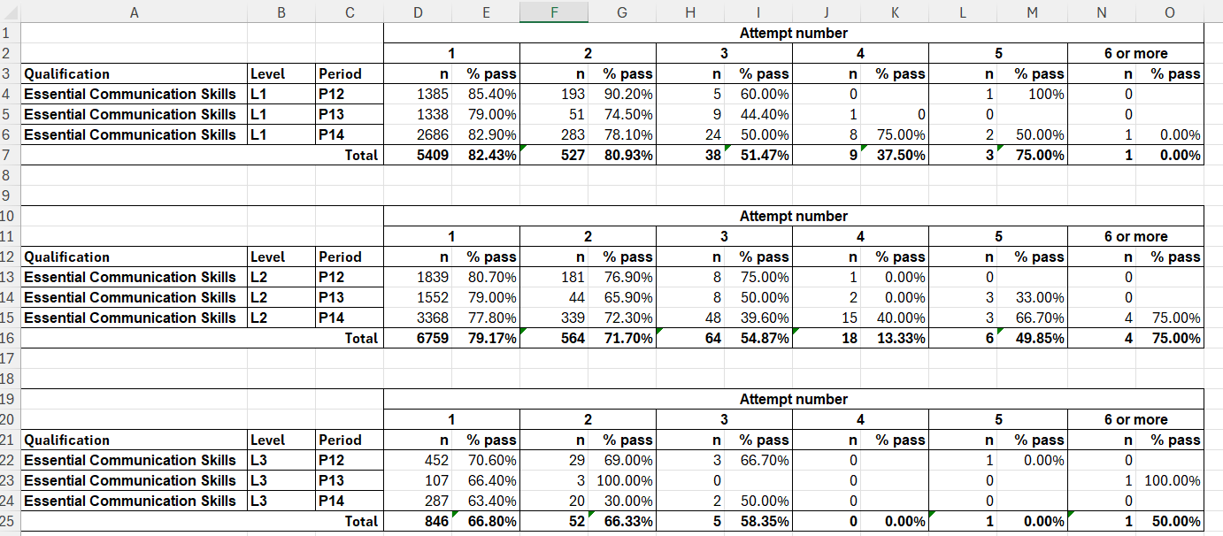

**AMG resits data**

(P12: May to Oct 2023; P13: Nov 2023 to Feb 2024; P14*: March to May 2024)

